Data for this exercise: <https://drive.google.com/file/d/1_Zgi73vysPOzmVxziEiA5Fu7n_QPRZ1H/view?usp=sharing>

1. **Question:**

Find the 65, 85, 95 percentile values of reading score

**Answer:**

To find the 65 percentile type =percentile(<select the reading score array>, 0.65)

To find the 85 percentile type =percentile(<select the reading score array>, 0.85)

To find the 95 percentile type =percentile(<select the reading score array>, 0.95)

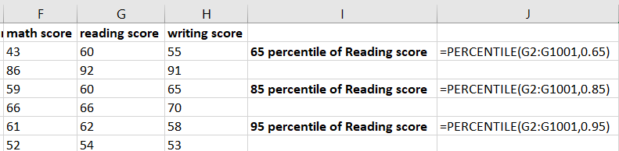

<press enter>

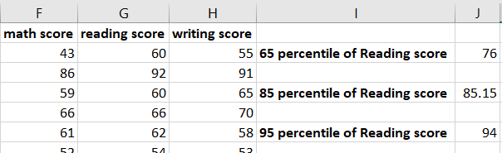

1. **Question:**

From the given data find the outliers in math score

**Answer:**

To find Q1: type =percentile(<select the math score array>, 0.25)

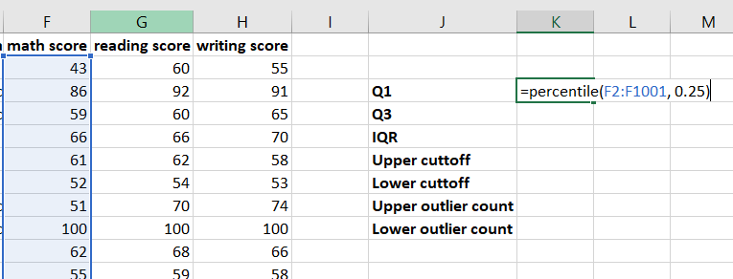

<press enter>

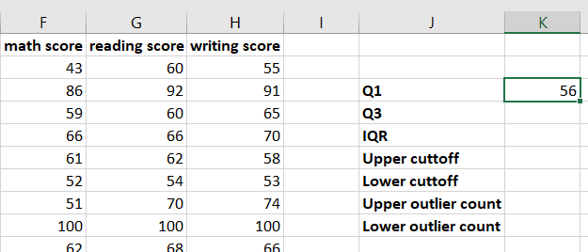

To find Q3: type =percentile(<select the math score array>, 0.75)

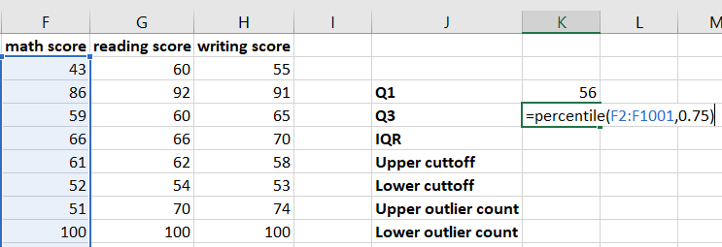

<press enter>

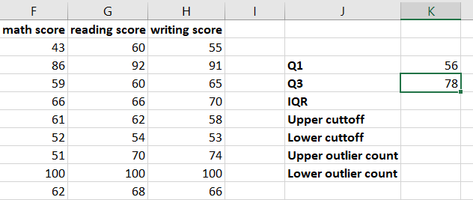

To find IQR: type =<Q3 cell>-<Q1 cell>

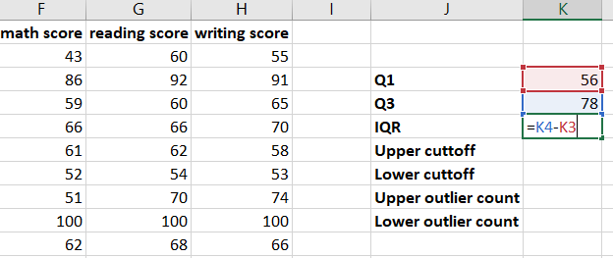

<press enter>

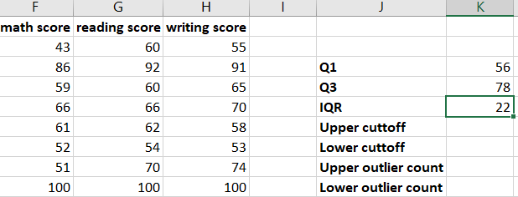

To find upper cutoff: type = <Q3 cell>+1.5*<IQR cell>

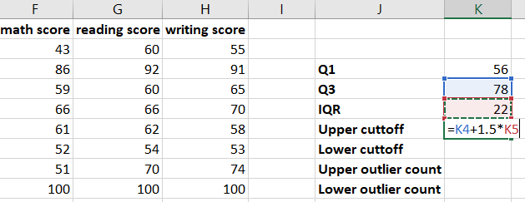

<press enter>

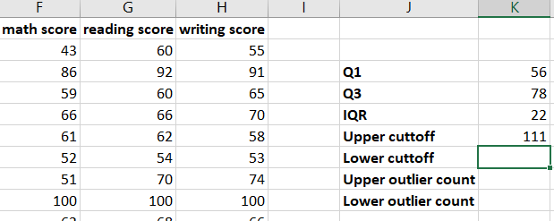

To find lower cutoff: type =<Q1 cell>-1.5*<IQR cell>

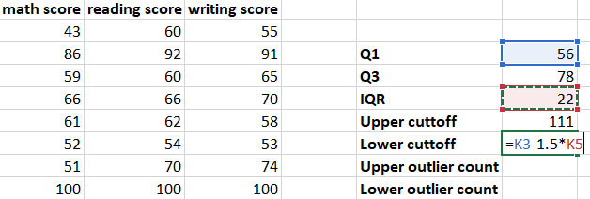

<press enter>

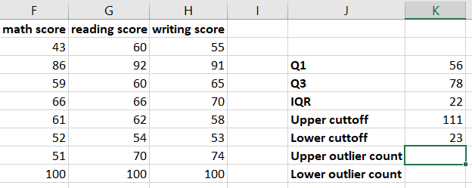

To find upper outlier count: type =countif(<select the math score array>,”greater than symbol<upper cuttoff cell>”)

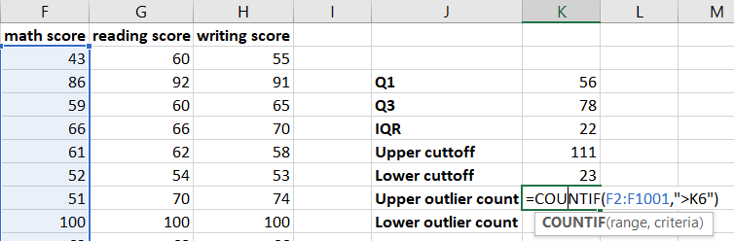

<press enter>

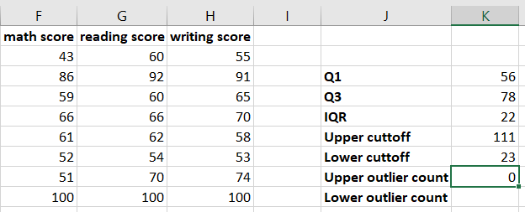

To find lower outlier count: type =countif(<select the math score array>,”lesser than symbol<lower cuttoff cell>”)

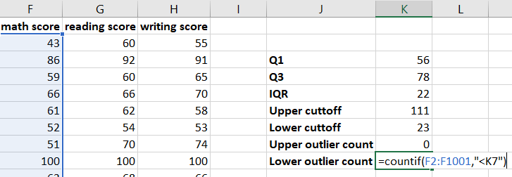

<press enter>

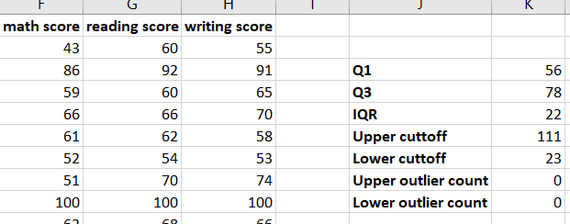

1. **Question:**

Find the count of missing values in the whole data

**Answer:**

To find the missing value count from whole data: type =countblank(<select the whole range>)

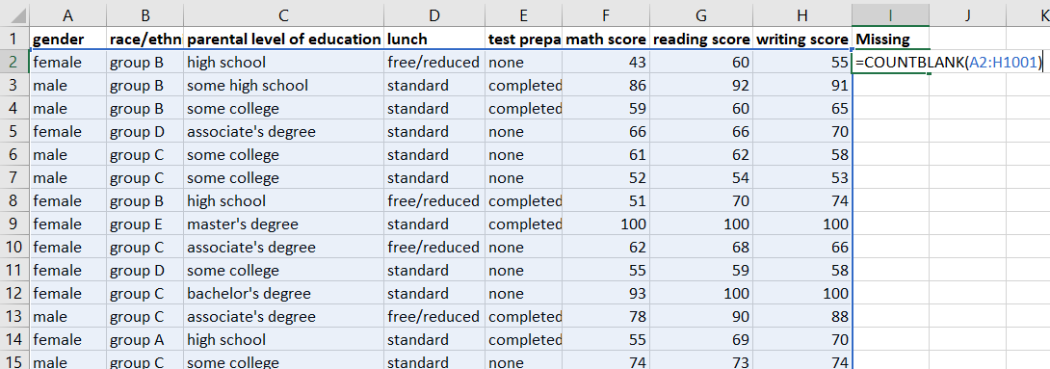

<press enter>

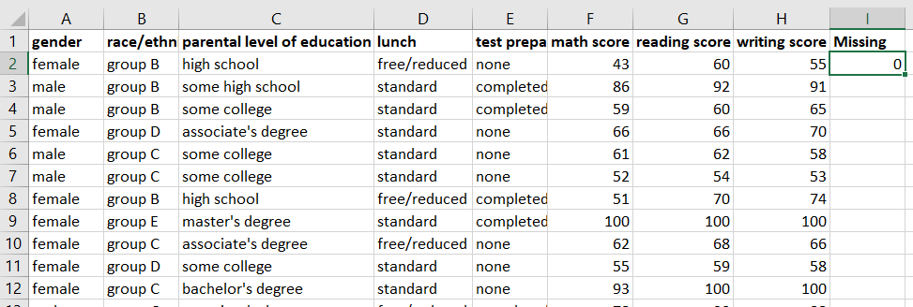

We have no missing values in the data